**Guidelines for Apex Oracle Application Express**

Download the latest version of Oracle Application Express from below url

www.oracle.com/database/technologies/xe-prior-releases.html

**Step-1 Download Oracle Database 11g Edition:**

In the middle of the screen, you'll see a System Type label, and next to it will say either 32-bit or 64-bit Operating System.

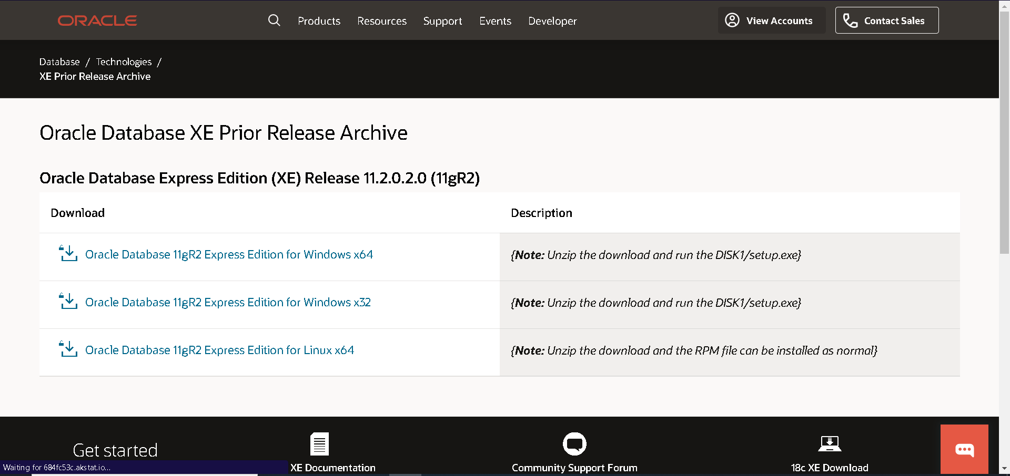

* Once you click on the right version of the Oracle download file, you'll be prompted with a Sign in screen.

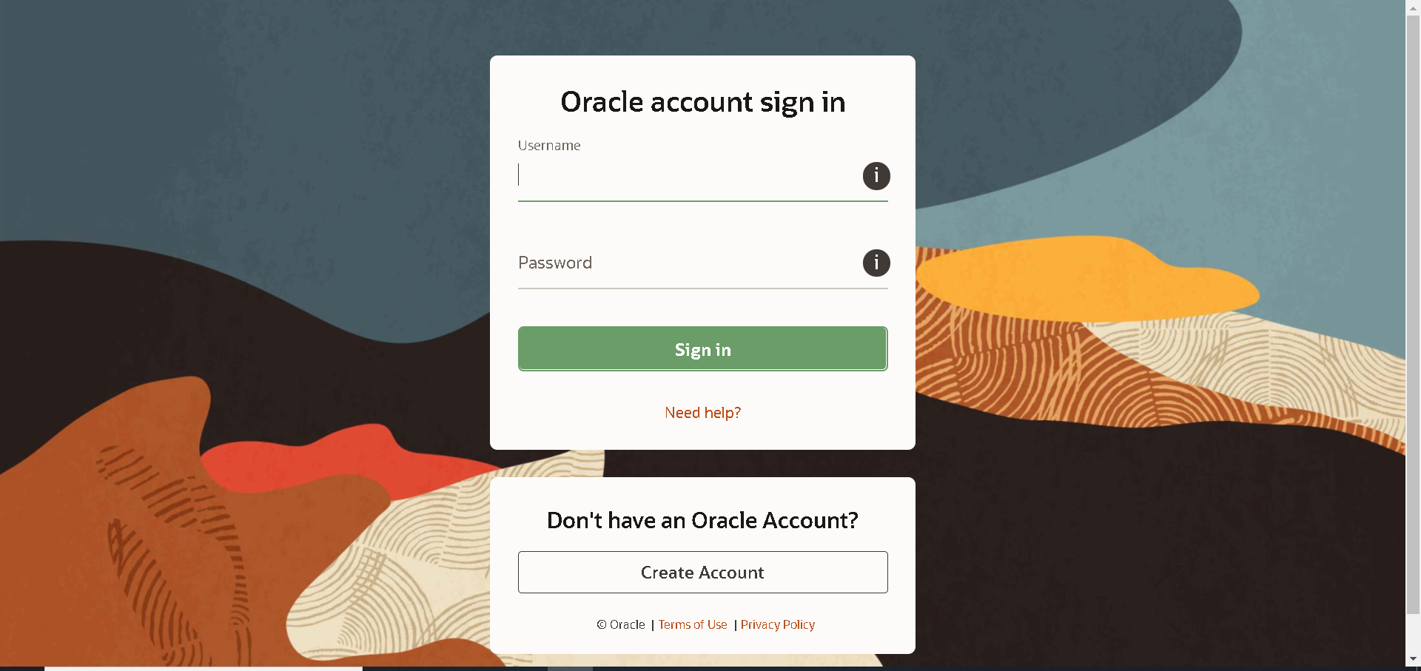

After Login, download will start

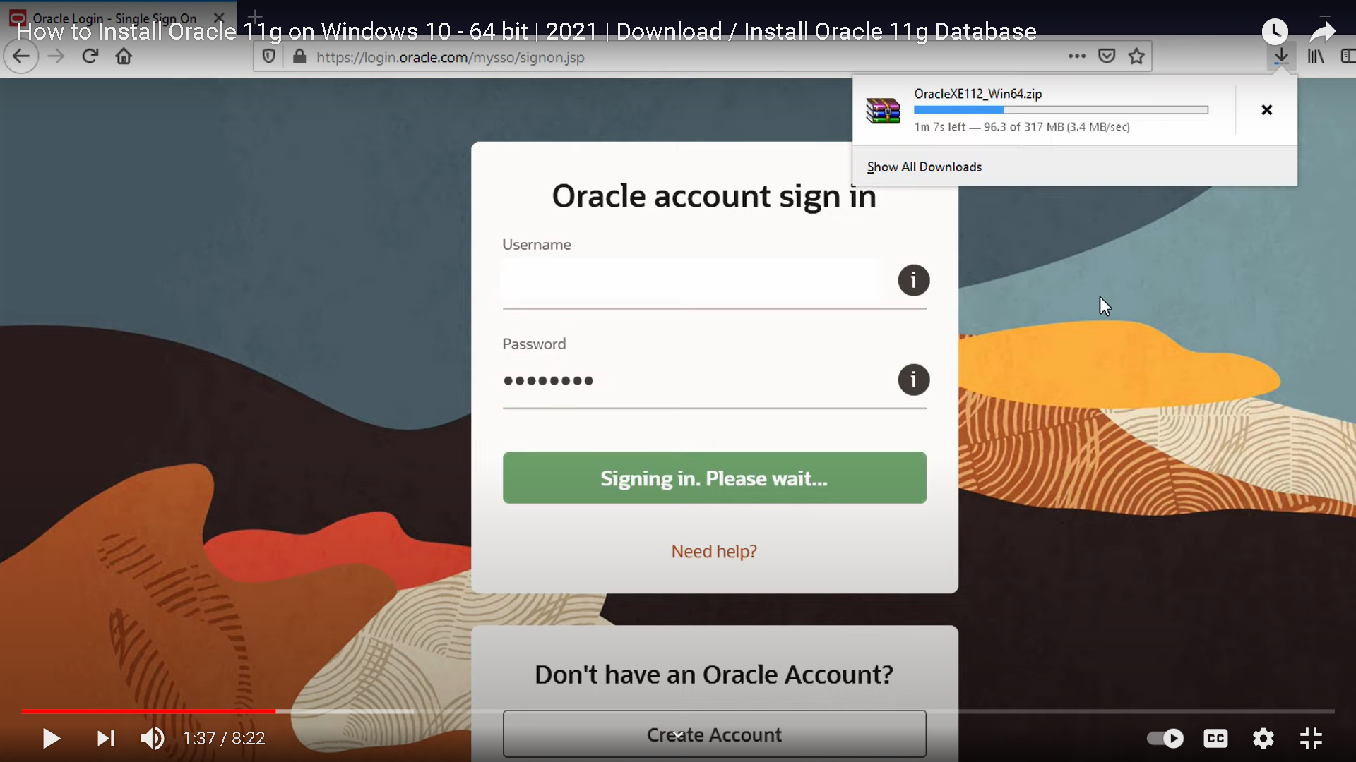

**Step-2 Installation**

After you have downloaded, then extracted the file ..you will get 3 files in it, you just have to run the setup and wait till it succeed on disk

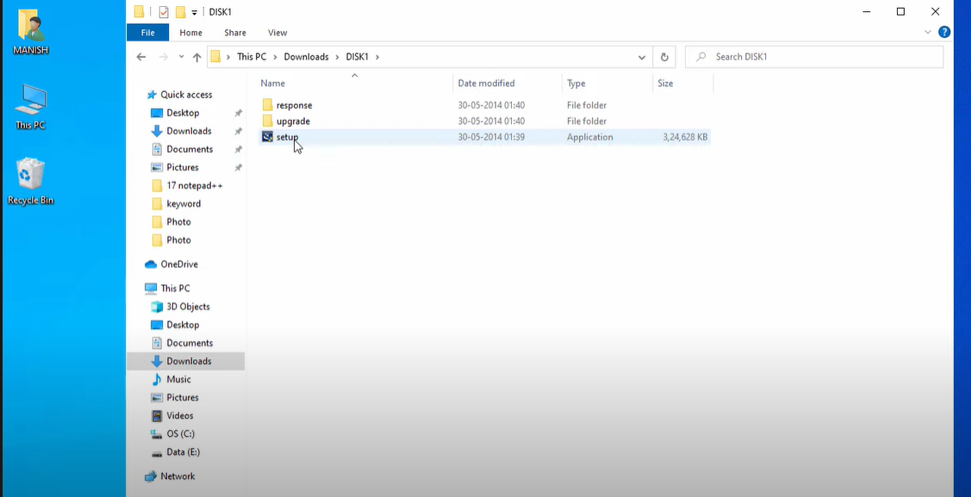

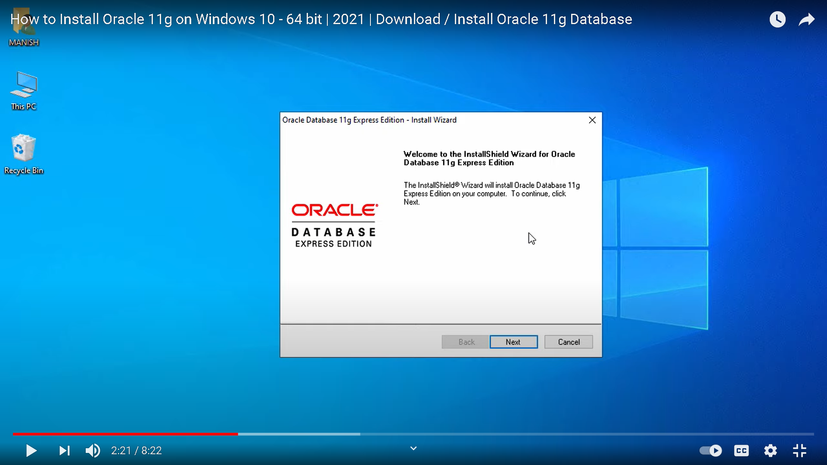

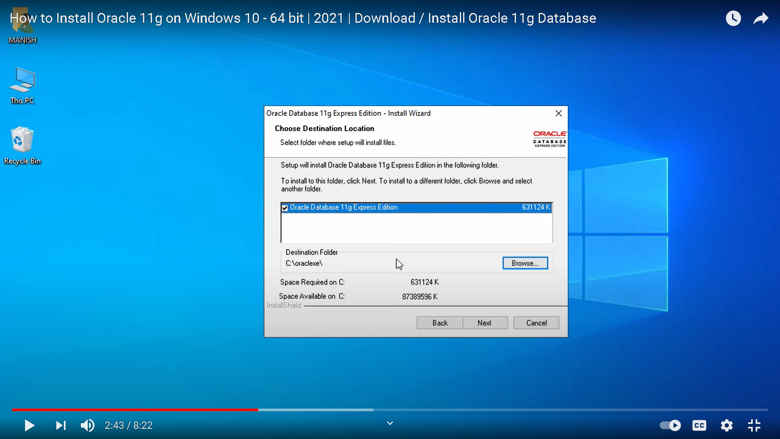

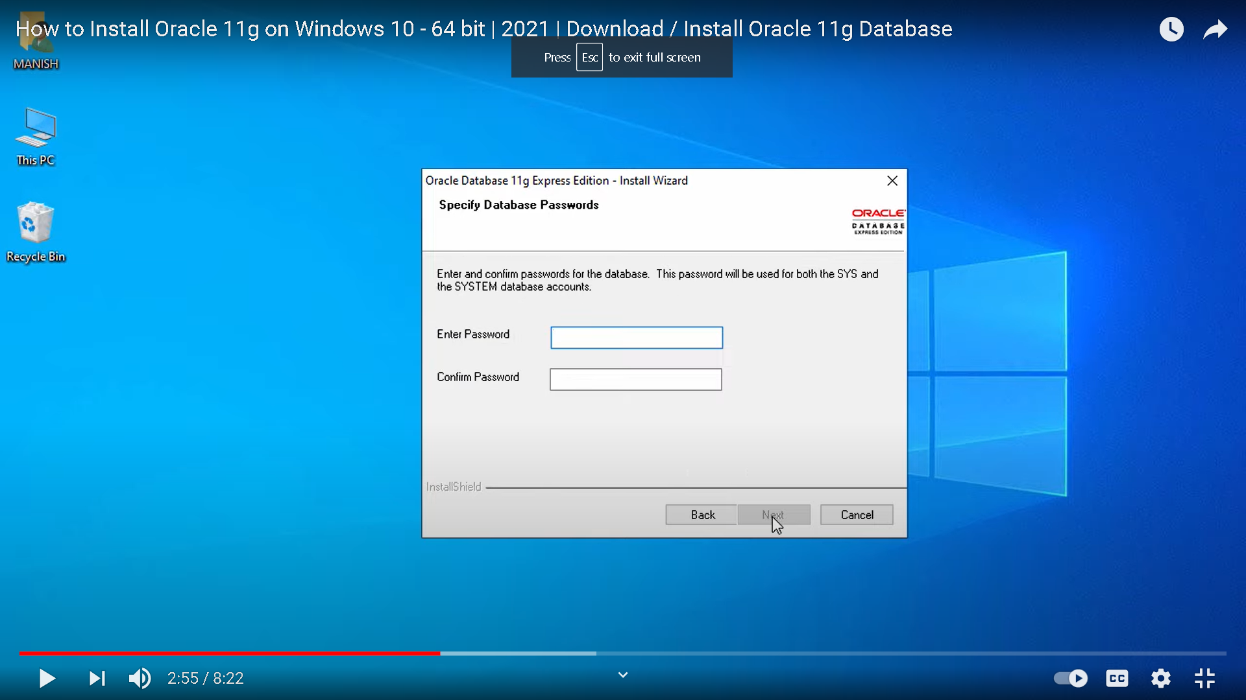

* Give password which should be easy, after password it will start to install

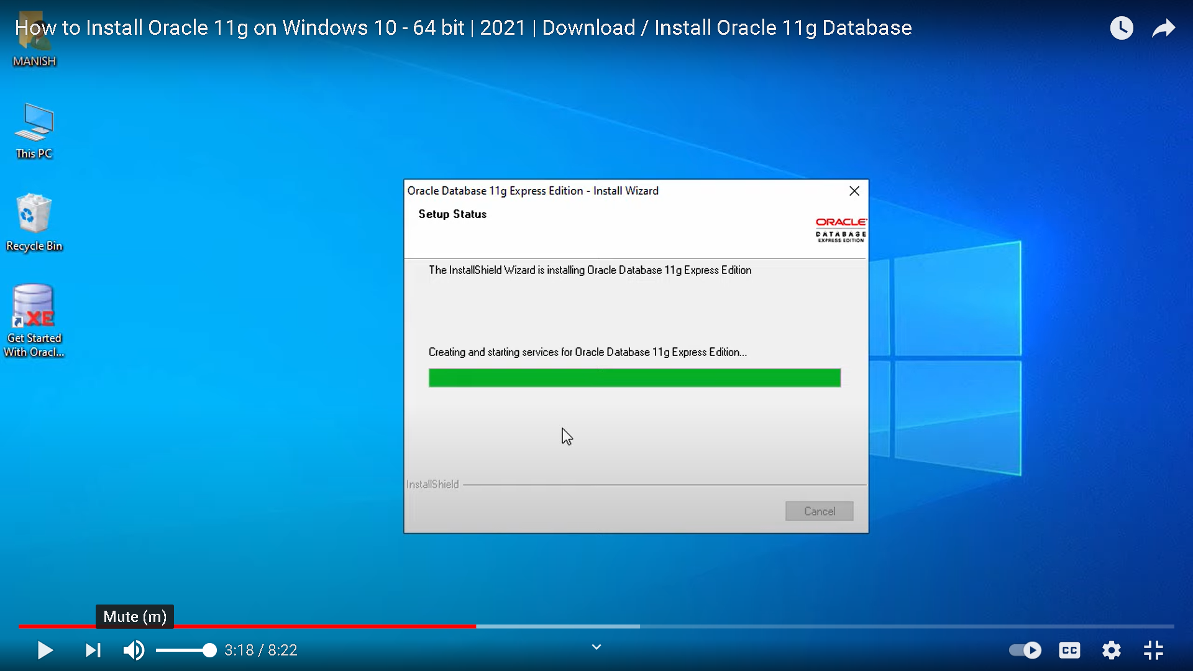

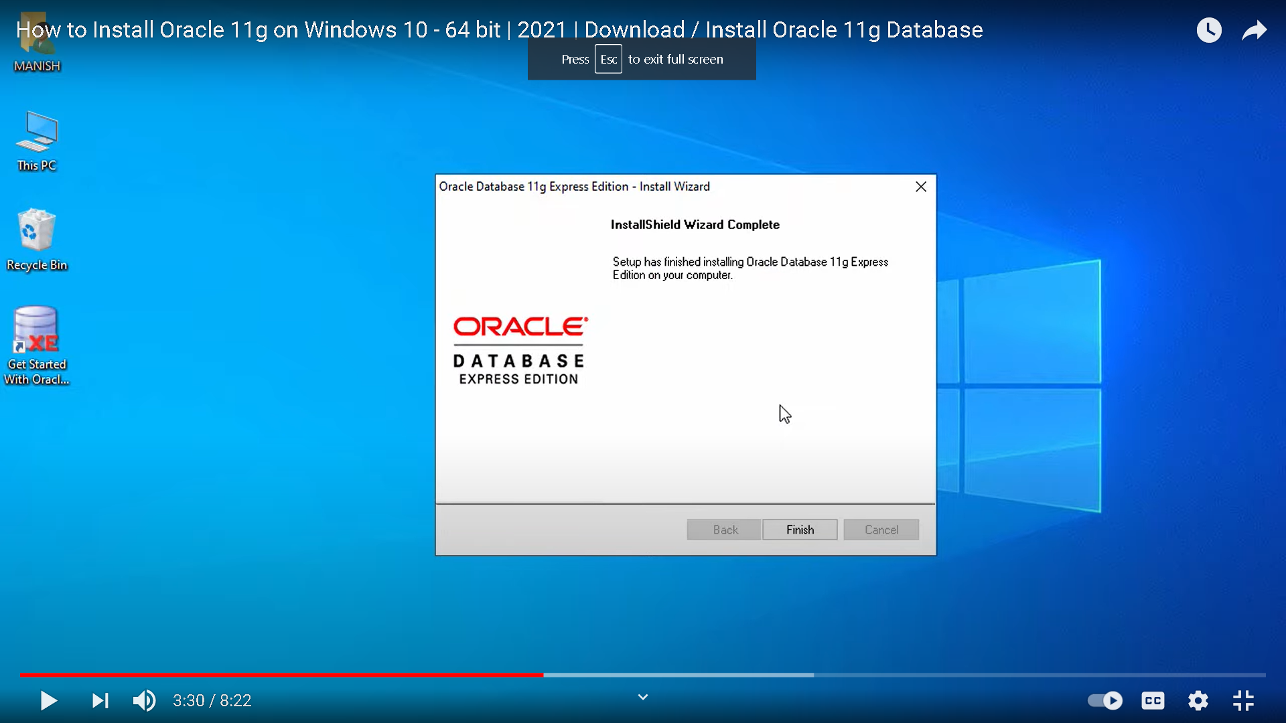

**Step-3 Get started with oracle** will be seen on desktop during this

After this, open it

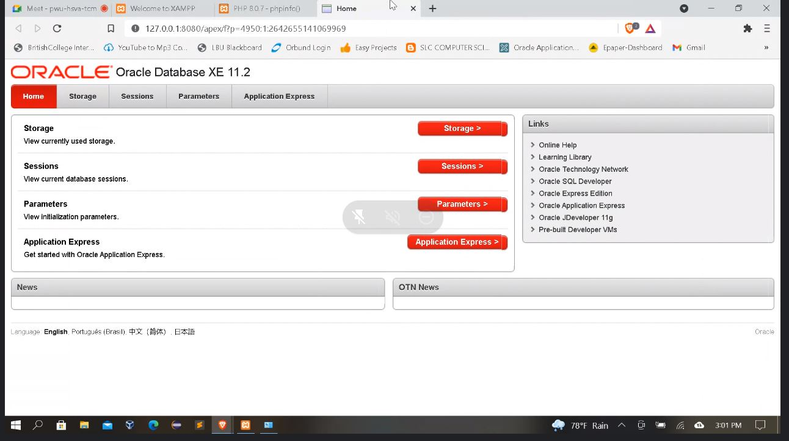

Click On Application Express

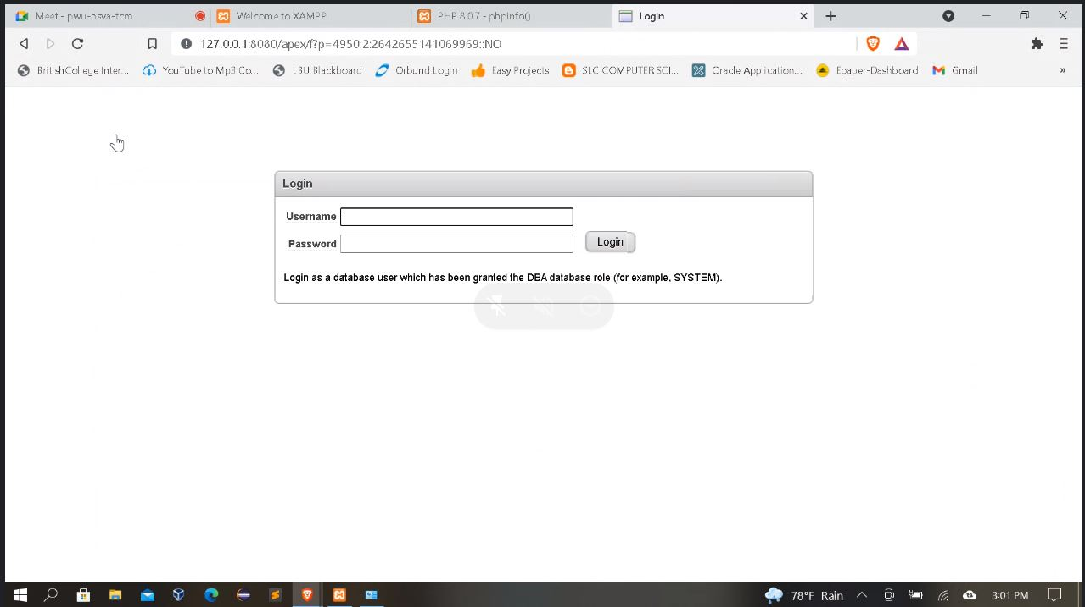

Put **system** as username

And put any new password

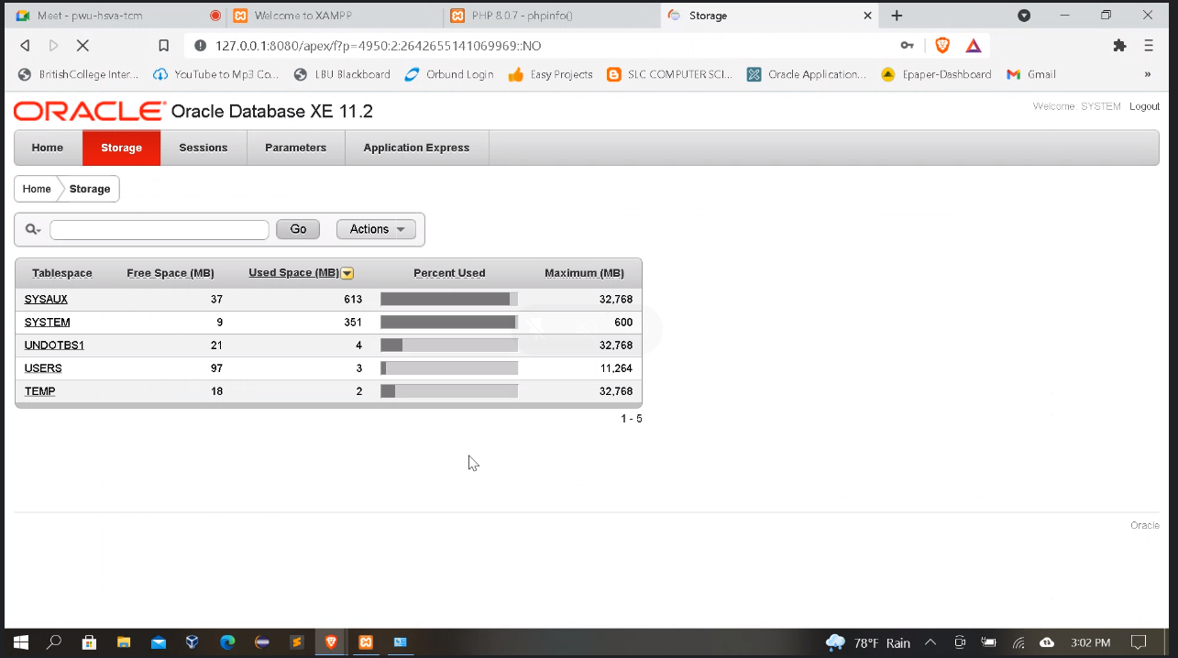

**Step-4**

Now you will need to download OCI 8 in c drive for OCI connection

<https://pecl.php.net/package/oci8/3.0.1/windows>

1. thread safe(TS) x64

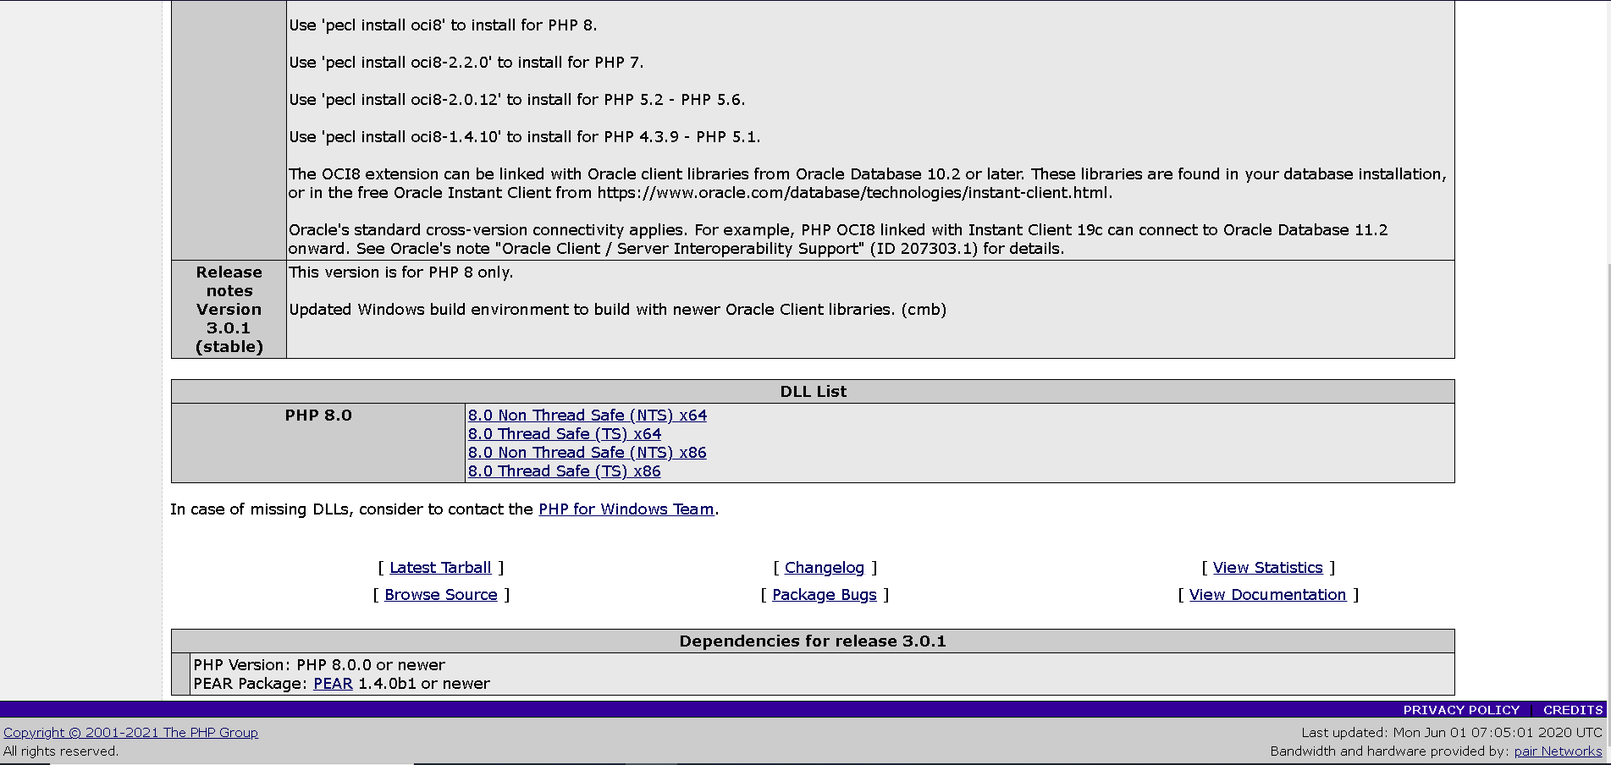

**Step-5 Download**

Instant client basic package downloads in c drive

<https://www.oracle.com/database/technologies/instant-client/winx64-64-downloads.html>

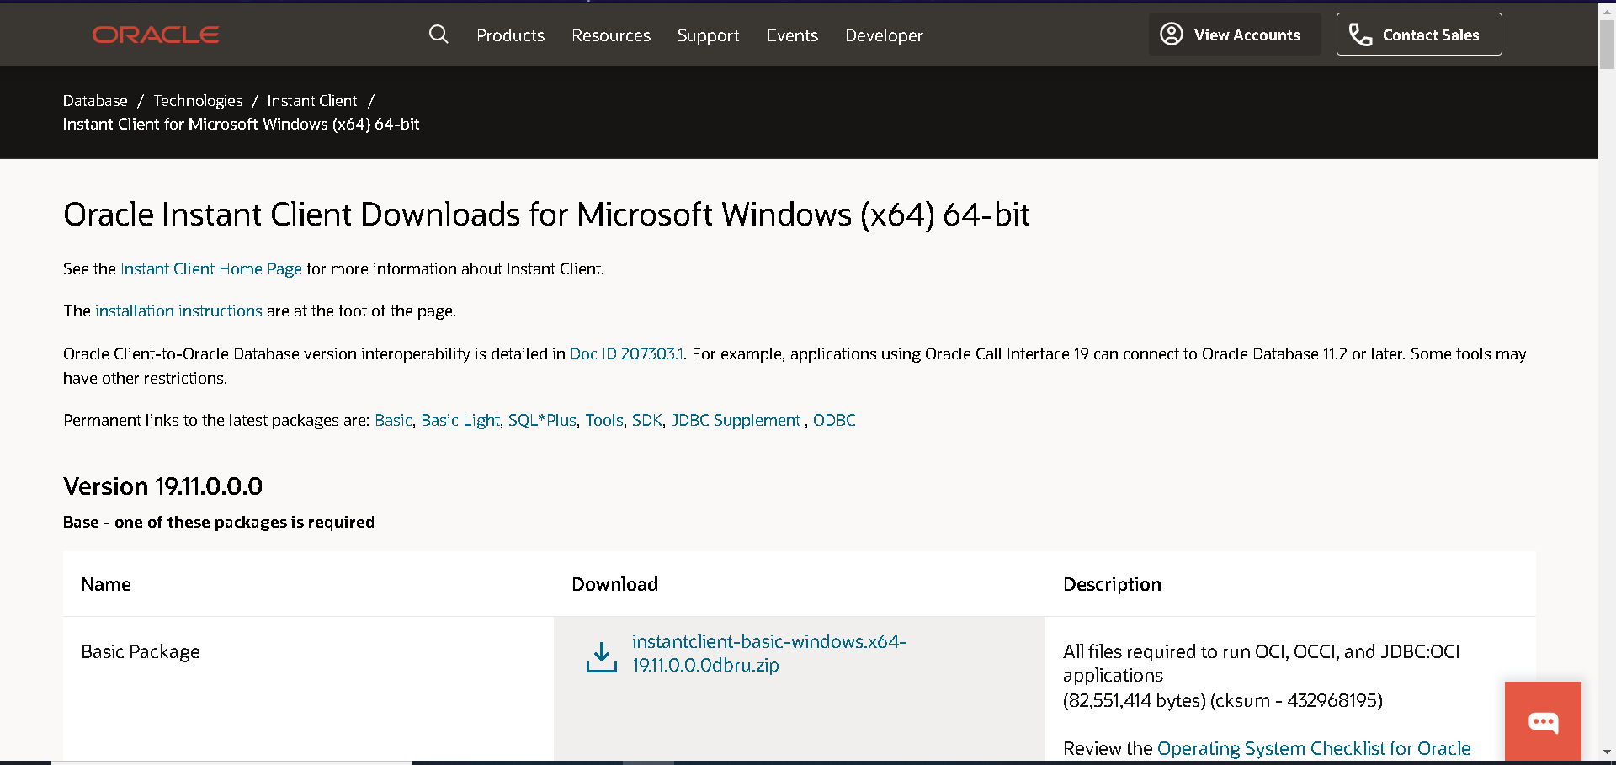

**Step-6 Setup** environment variable

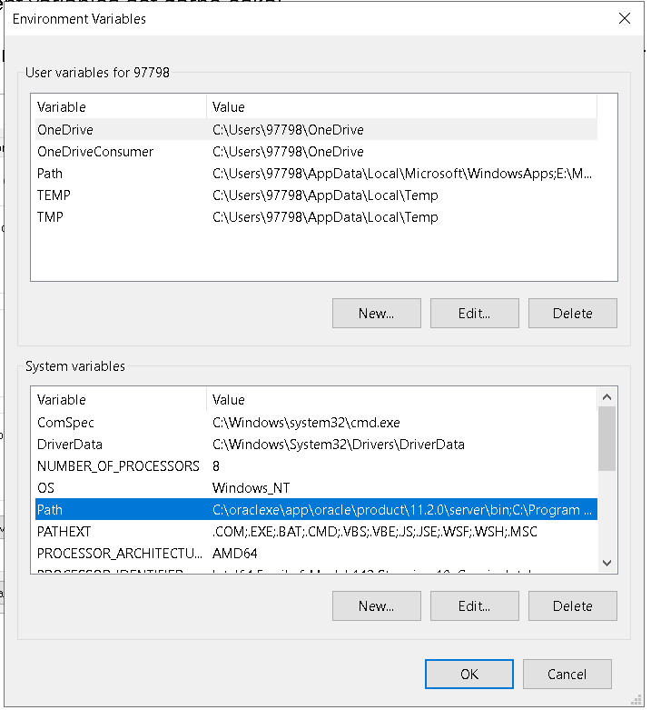

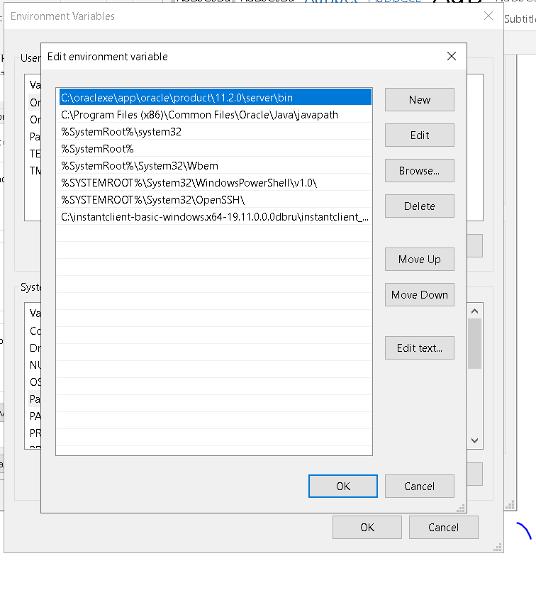

Paste the file location address of install client and create new variable

**Step-7 Download apex 19.2**

Download and extract the apex 19.2 file and copy the **Apex** folder inside it and paste it in C drive.

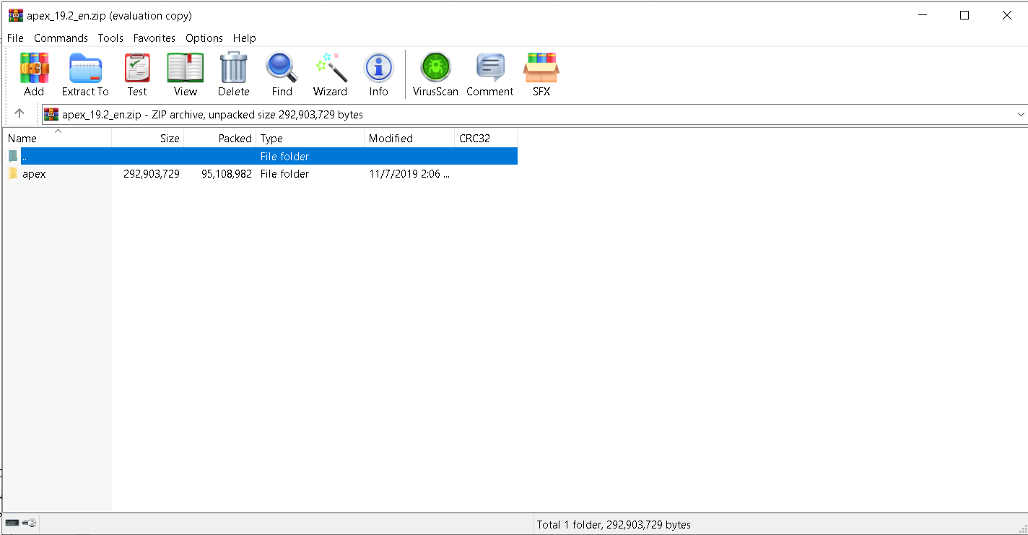

**C drive will look like this after downloading all the files**

Oci8, instant client, apex and xampp (8.0.0 version above)

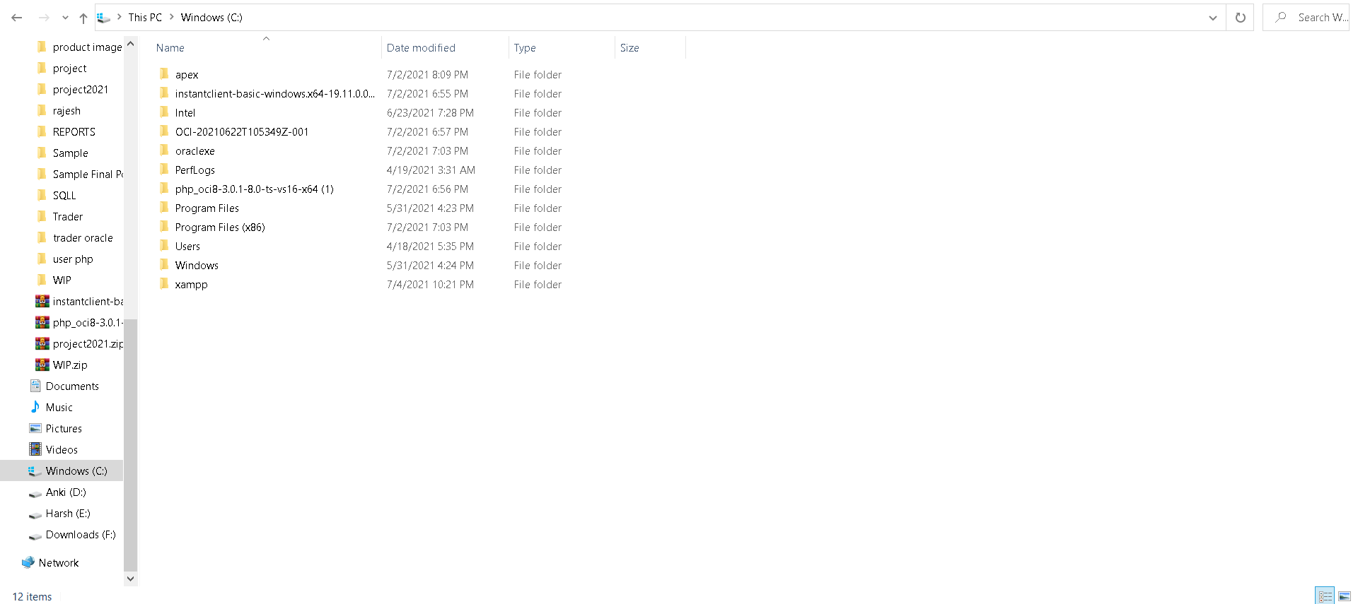

**Step-8**

**Copy and paste the 4 dll file from php_oci8-3.0.1-8.0-ts-vs-x64 to xampp -> php -> ext**

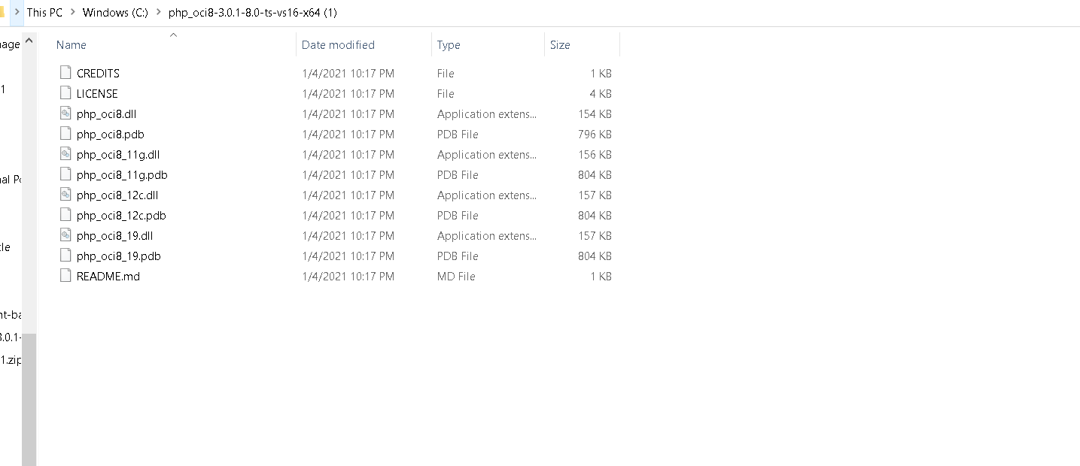

Replace and copy here

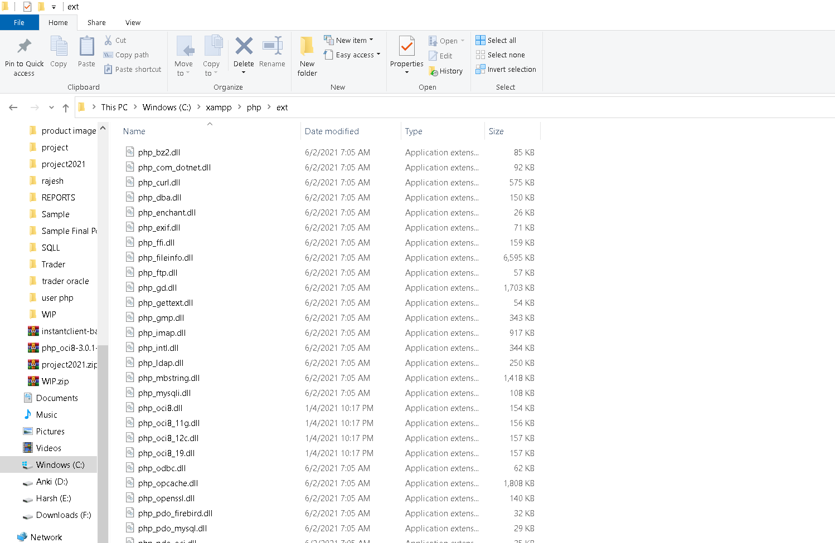

**Step-9**

**Then go inside php.ini file which is inside C-> xampp->php**

And uncomment these two lines and save it

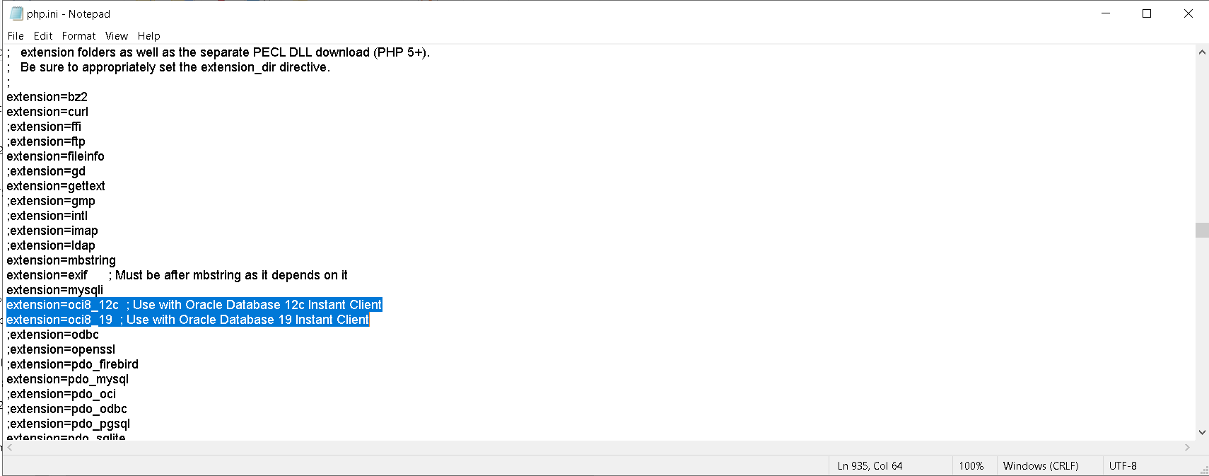

**Step-10**

**Also you need to update the sendmail.ini inside xampp->sendmail and provide your email and password of that email inside it**

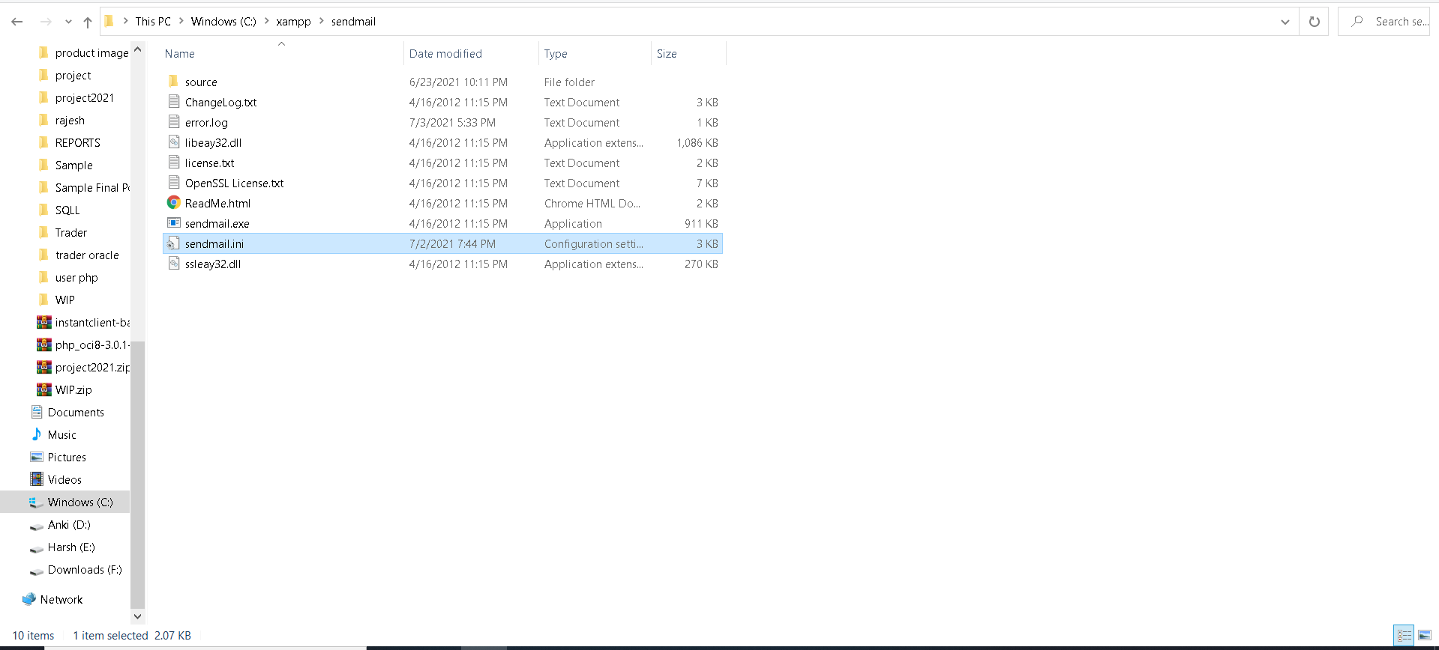

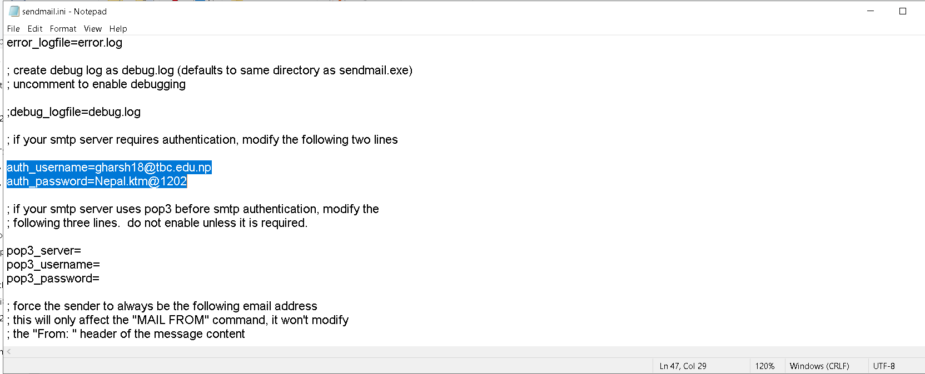

**Step-11**

After this, you need to go inside the apex folder and press shift key and right click at once, then dialog box appears

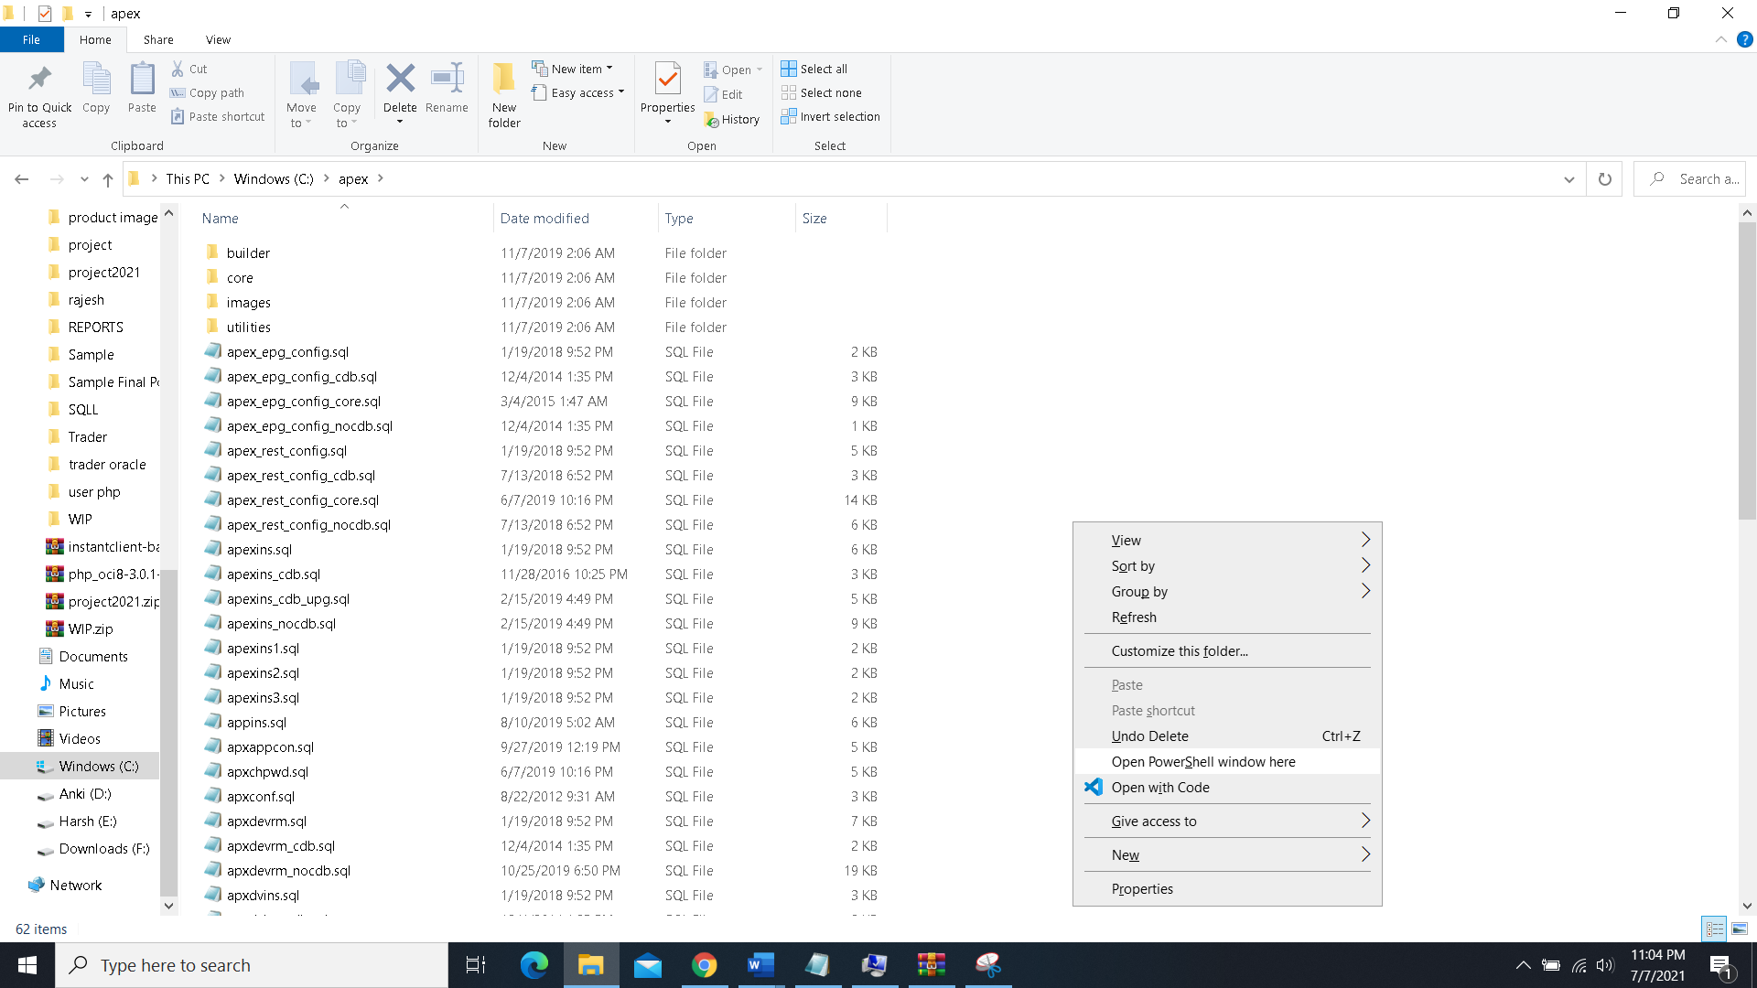

* Then we need to click on **OPEN POWERSHELL WINDOW HERE** as shown above

Power shell window opens:

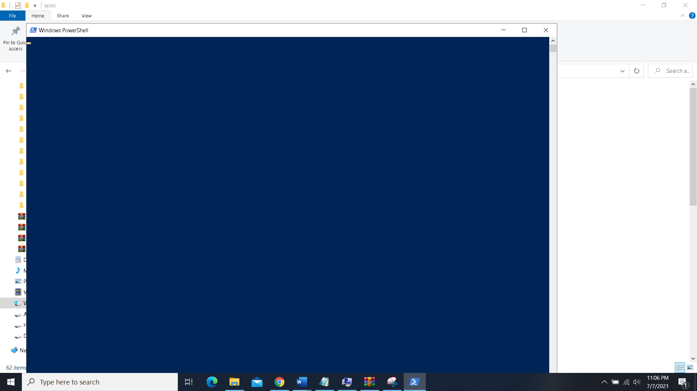

**Step-12**

In the PowerShell, we need to cut, paste run the following command one by one for upgrading apex

=================

1. Unzip to c:\ Drive

2.

Change directory to apex

c:\>apex sqlplus /nolog

3.

SQL> CONNECT SYS as SYSDBA

Enter Password

4.

@apexins SYSAUX SYSAUX TEMP /i/

After Completing you will be switch for c:\>apex

sqlplus /nolog

CONNECT SYS as SYSDBA

5.

@apex_epg_config.sql C:\

Note: APEX_HOME is the directory you specified when unzipping the file. For Example with WIndows 'C:\'

Final Message will be Commit Complete.

If you need to create the admin account type this and provide email and password

6.

@apxchpwd

**Screenshots of some processes of above steps:**

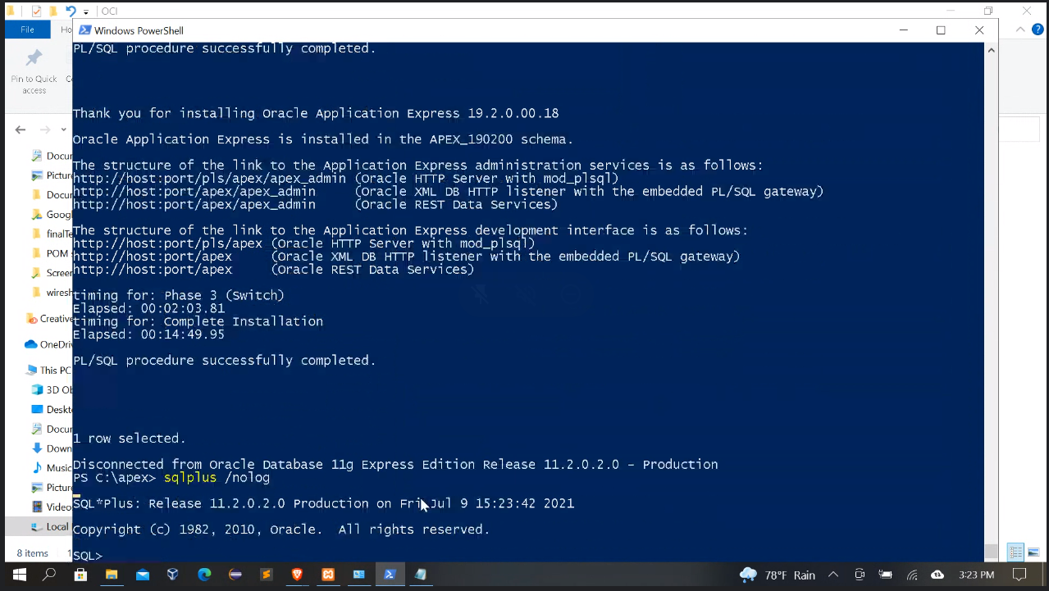

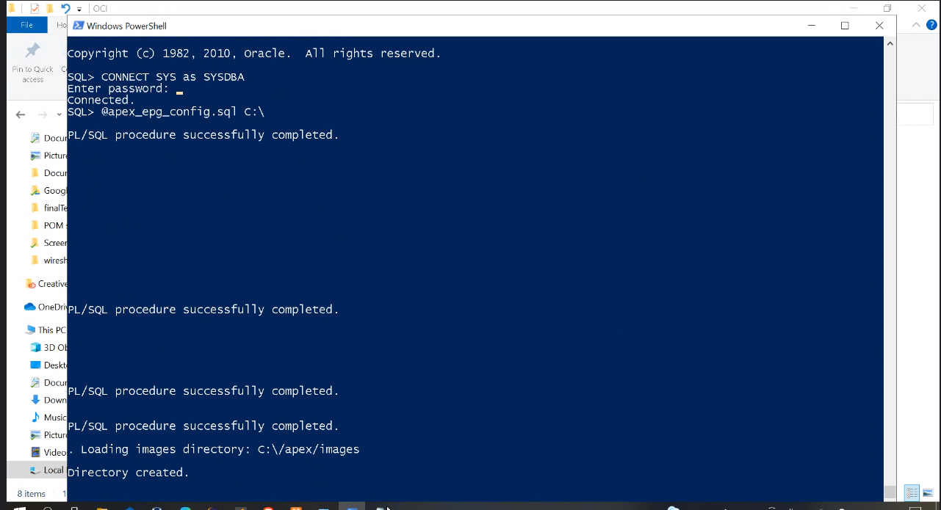

Enter administrator username,passord,email

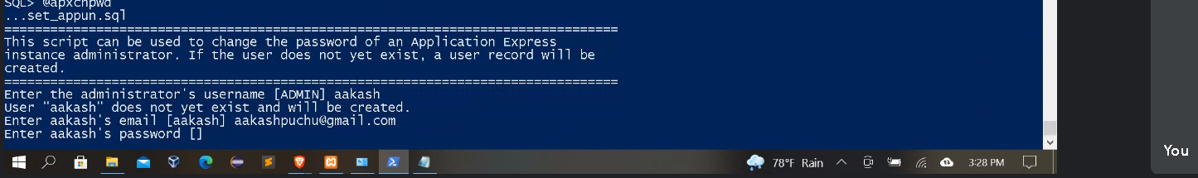

Oracle connected

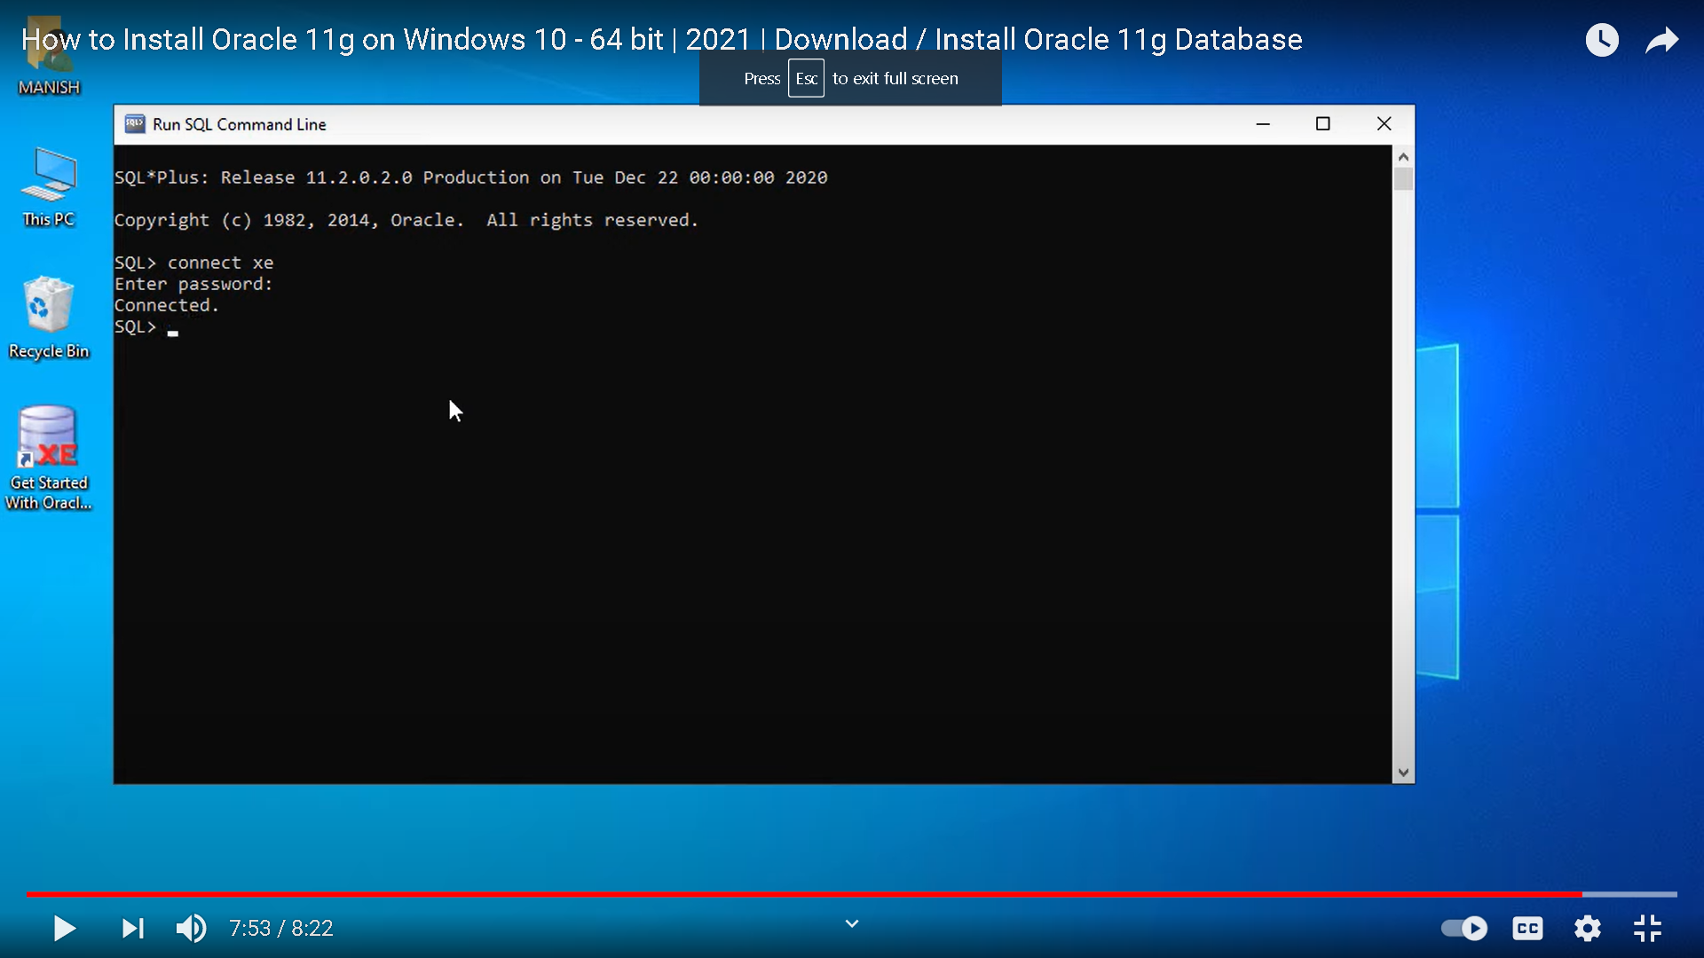

**Step-13**

If all above process is successful, **you should check Oci8 in phpinfo.php in localhost** as below,then you are good to go with your website

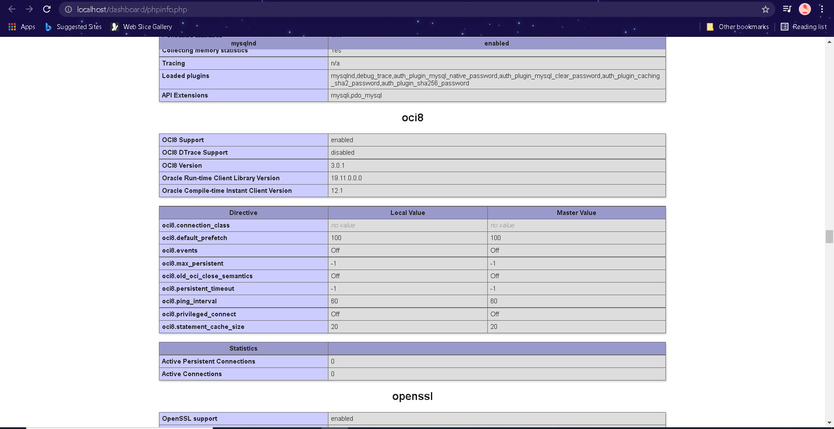

**Step-14**

How to create new workspace

7. localhost:8080/apex/apex_admin after starting xampp

in Username, enter ADMIN

in Password, Enter the Password entered in Step6

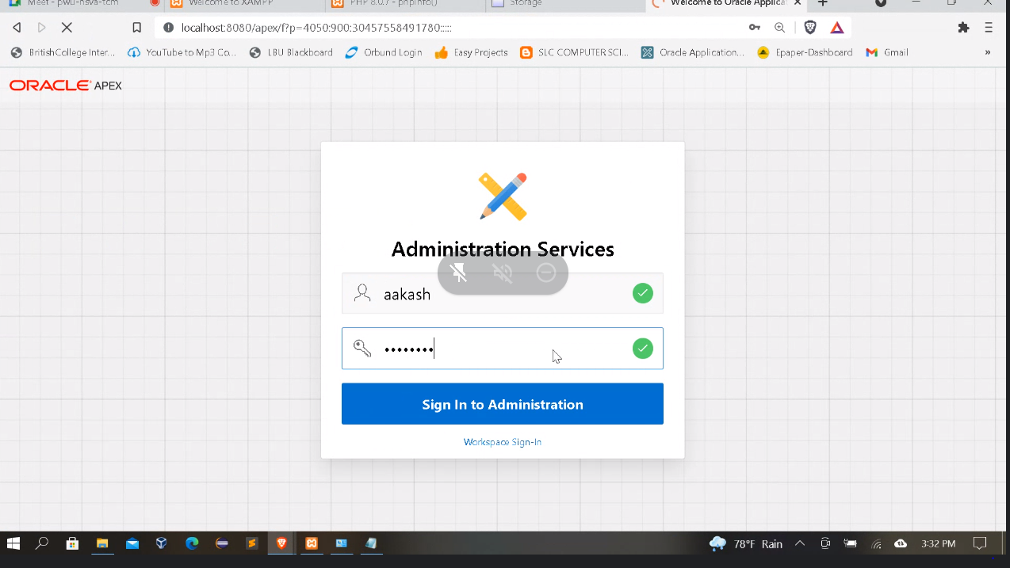

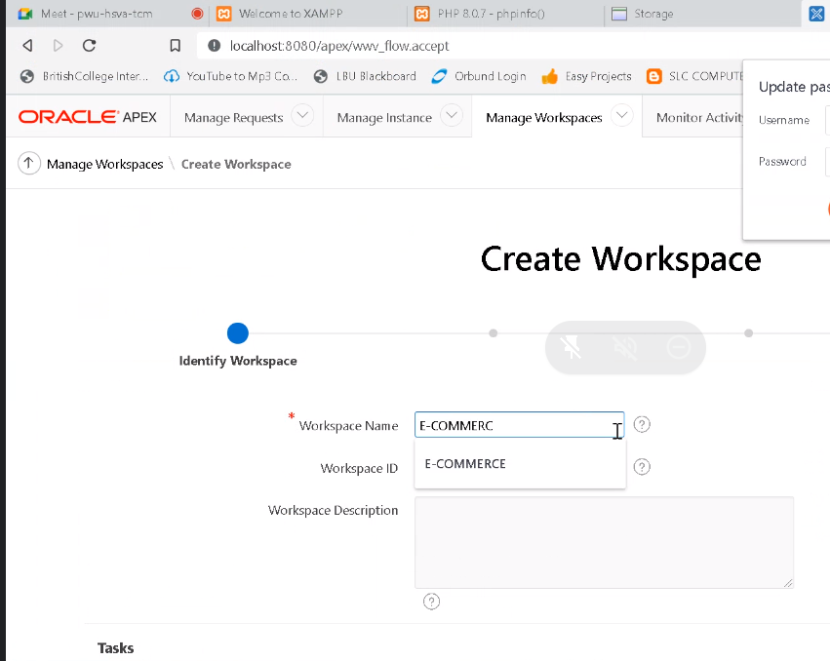

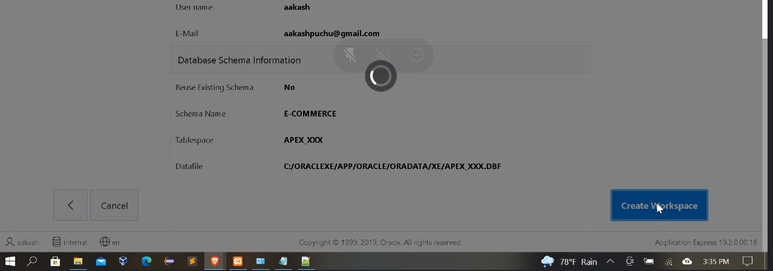

**Step-15**

**After creating workspace,**

you will update your password, remember the **scheme name** and its password which is needed in connection.php of website to access localhost and run website successfully

Login oracle apex looks like this

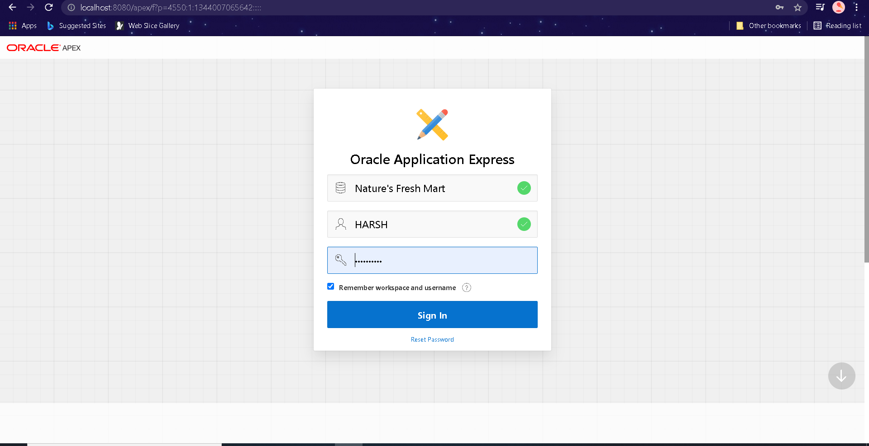

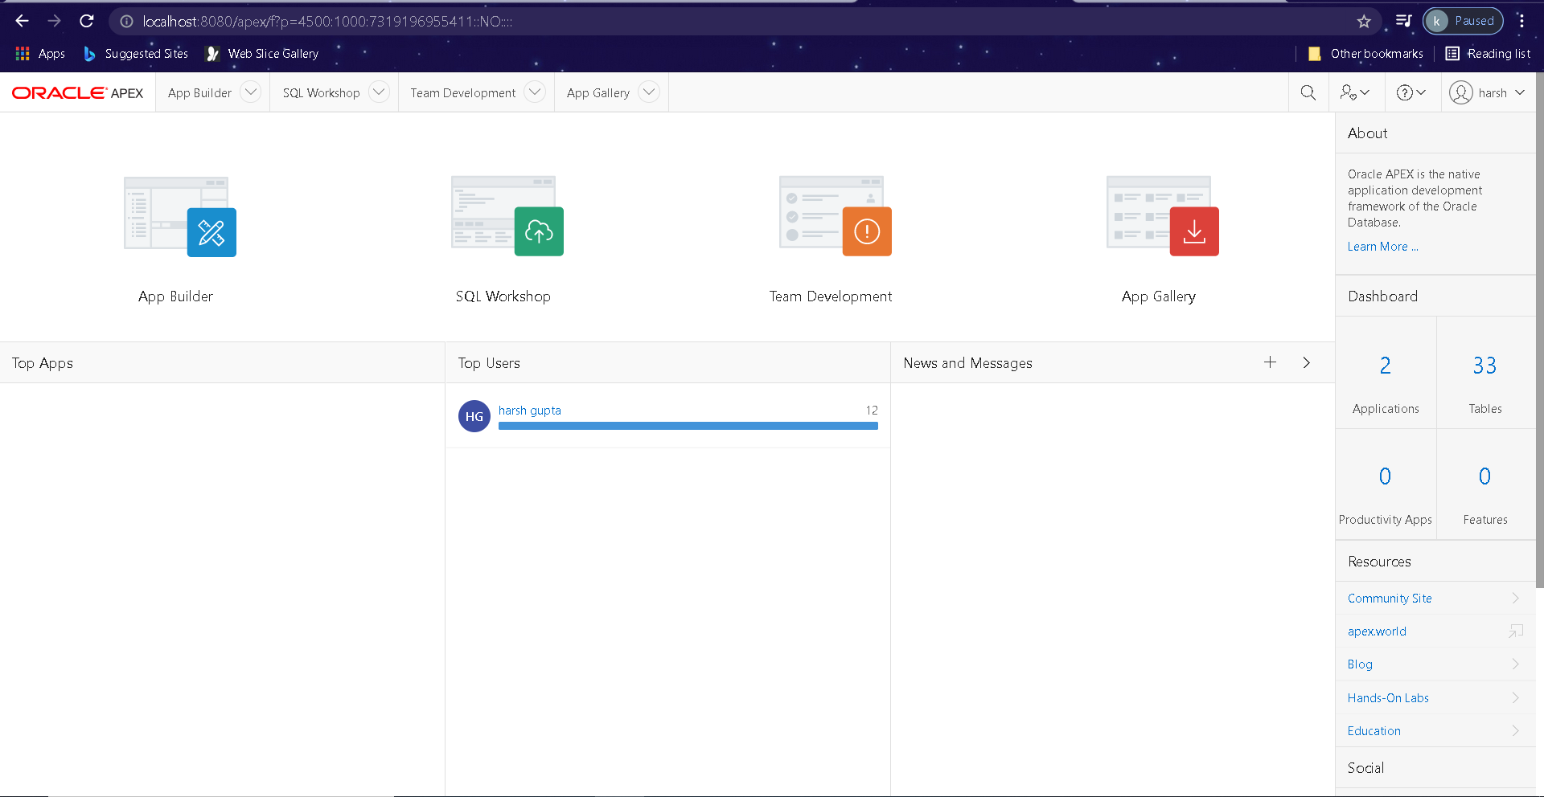

**Step-16**

In order to make connection, scheme name= E-COMMERCE (YOUR **SCHEME NAME**)

Password (**Your** **scheme** **password**)

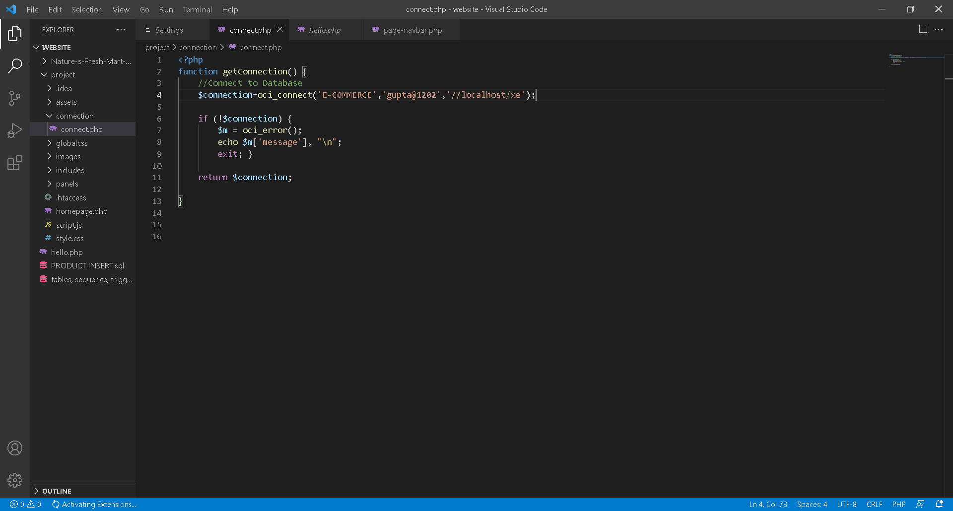

Then you can view any php website or create and connect to database easily

